**USE CASE: Start a free trial**

Document History

Document Location

This is a snapshot of an on-line document. Paper copies are valid only on the day they are printed. Refer to the author if you are in any doubt about the currency of this document.

The source of the document will be found …

Revision History

|  |  |  |
| --- | --- | --- |
| Revision Number | Revision Date | Summary of Changes |
| 1.0 | 7/1/2013 | Initial document |
| 1.1 | 7/5/2013 | Revised |
|  |  |  |
|  |  |  |

Approvals

This document requires following approval signature. Signed approval forms are filed in …

|  |  |
| --- | --- |
| **Name** | **Title** |
|  |  |
|  |  |
|  |  |
|  |  |

Distribution

This document has been distributed to:

|  |  |
| --- | --- |
| **Name** | **Title** |
|  |  |
|  |  |
|  |  |
|  |  |

Contents

1. Introduction 5

1.1 Purpose 5

1.2 References 5

1.3 Notation/Structure 5

2. Use Cases 6

2.1 Use Case Name: Start a free trial 6

2.1.1 Use Case Overview…. 6

# Introduction

Use Cases are detailed descriptions of how users and systems interact with an application. These descriptions include ideal paths with alternate paths and post conditions. This information assists the structure and interface design for the best possible experience for the site’s users. Additionally, the Use Cases are used by the QA team to ensure all objectives and requirements were met and fulfilled successfully.

A set of Use Cases can be created to describe the majority of user interactions with the application. The Use Case will ultimately drive the User Experience team in defining the interface. With a clear distinction between user and system interactions written in use case form the UI can be developed in more detail.

Each Use Case follows and tracks back to business requirements.

## Purpose

This document describes the Use Cases for the outlined system.

Use Cases are used to explore and communicate the likely actions of users and the system when interacting with the application. Development of Use Cases helps the design team understand the business requirements and how they can ultimately drive the design and user experience.

## References

This document is based on the following documents:

* Document Name

## Notation/Structure

Use Cases typically have the following sections:

1. Overviews
2. Preconditions
3. Triggers
4. Main Flows
5. Alternate Flows
6. Business Rules
7. Messages (system generated)

# Use Cases

## Use Case Name: Start a free trial

### Use Case Overview….

|  |  |  |
| --- | --- | --- |
| **Use Case ID** | **Start a free trial** | |
| **Use Case Overview** | A user can click through from the free Cosentium site to sign up for a trial account. A trial account exposes all the features of a paid account for a limited period of time. A trial account, if the customer continues to use it beyond the trial period duration, becomes a paid account. This use case only covers the establishment of the trial account and the super user custodian. The user that clicks through from the free site to sign up for the trial account becomes the super user (system admin) for the account they are establishing. | |
| **Precondition** | 1. User selects "sign up for free trial" on the free Cosentium marketing site, or is directly linked to the sign up page from another web site, an email, etc.. | |
| **Trigger(s)** | 1. User selects "sign up for free trial" on the free Cosentium marketing site, or is directly linked to the sign up page from another web site, an email, etc.. | |
|  | | |
| **B - Main Flow** | | |
|  | B1 | System displays user data form titled "Sign up for your free trial" for the system user with the following fields:<first_name> (labeled "First Name") accepting text entry, <last_name> (labeled "Last Name") accepting text entry, <email_address> accepting properly formatted email address, <job_title> (labeled "Job Title") accepting text entry, <phone> (labeled "Phone") accepting numeric entry, <company> (labeled "Company") accepting text entry, <number_employees> (labeled "Employees") allowing selection from a drop down list consisting of choices "1 to 5", "6 to 15", "16-50", "51-150", "151-500", "501-2,500", "2,501-10,000", "10,001-25,001", "over 25,001"; and <csa_agree> (labeled "I agree to the Commercial Services Agreement" and formatted as a checkbox that is unchecked by default. The text "I agree to the Commercial Services Agreement" is formatted as a hypertext link that the user can click through in order to access and review the Commercial Services Agreement). On the bottom of the form, the user can click on a button with the label "Begin Free Trial". |
|  | B2 | The user fills in all the fields  The user checks the box for "I agree to the Commercial Services Agreement"  If user clicks on the hypertext formatted "I agree to the Commercial Services Agreement", another browser window spawns displaying the Commercial Services Agreement. The user can scroll through the whole document and print it if desired. |
|  | B3 | User clicks ‘Begin Free Trial’. |
|  | B4 | System validates user selections. The rules for validation are:  1. All fields must have entries in them  2. The "I agree to the Commercial Services Agreement" checkbox must be checked  3. The phone number field can contain only numbers  3. The email address must be properly formed  4. The combination of email address and company must be unique. Email cannot be associated with an existing user that is attached to this company account.  5. The company must be unique, not already existing in the system.  If validation fails, redisplay B1 with the entries the user provided, with red highlighting next to the field(s) that need to be corrected/completed, along with informative text in red to help the user know how to correct. The field correction help text to be displayed is as follows:  1. If a field has not been filled in, the red highlighted text displayed should say M1  2. If the email address entered is not properly formed, the red highlighted text displayed should say M2  3. If the phone number field contains text or other illegal characters that are not numbers, the red highlighted text displayed should say M6  4. If the email address is associated with an existing user that is attached to the account, the red highlighted text displayed should say M7  5. If the company of the same name already has an account in the system, the red highlighted text displayed should be M8. |
|  | B5 | System executes a task to send user an email to the email address provided in B1. The email contains a system generated user specific link for the user to click through in order to get to the login page. The email content should be in plain text format.  System displays a splash page titled, "Your free trial is ready to use" and with instructions that advise the user to "1. Check your email ", "2. Login to Cosentium", "3. Start using Cosentium". The page also displays the text "Need Help? Call us at 800.xxx.xxxx" |
|  | B6 | User clicks on emailed link |
|  | B7 | System displays "change password" form. The page says, "Welcome to Cosentium! For security purposes, your password must now be changed."  The following fields are displayed with corresponding user entry boxes: <username> (Labeled "Username") autofilled with the user's username, <new_password> (Labeled "New password") accepting alphanumeric entry, <verify_new_password> (Labeled "Verify new password") accepting alphanumeric entry, <security_question> (Labeled "Question"), and a accepting selection from a drop down list of choices, <answer> (labeled "Answer") accepting alphanumeric entry.  The questions that are available for the user to choose from in the "Question" drop down list are:  - "What city were you born in?"  - "What was the name of your first pet?"  - "What is your mother's middle name?"  - "What is the name of an elementary school you attended?" |
|  | B8 | User clicks "Save"  System does validation as follows:  1. "New password" entry must consist of at least 8 characters and include at least one lowercase letter, one uppercase letter, and one special character.  2. "Verify password" entry must match the entry in "New password"  3. "New password", "Verify password", "Question", and "Answer" must all have entries.  If validation fails, redisplay B7 without the entries the user provided, with red highlighting next to the field(s) that did not pass validation, along with informative text in red to help the user know how to correct. The field correction help text to be displayed is as follows:  1. If "New password" entry does not pass validation, display M2 in red text next to or adjacent to the "New password" data entry box.  2. If "Verify password" does not match the entry in "New password", display M3 in red text next to or adjacent to the "Verify password" data entry box  3. If fields do not contain user entry, display M1 in red text adjacent or next to the data entry boxes that have not been filled in |
|  | B9 | System displays "Sign in" page. The page includes an entry box for <username> with a label of "Username" next to it (note <username> is not prefilled in this case- on subsequent logins it may be prefilled if the user has checked the "Remember me" box), an entry box for <password> with a label of "Password" next to it, a checkbox for <remember_me> with label of "Remember me" next to it (note <remember_me> checkbox is unchecked by default in this case- on subsequent logins it may be checked if the user has previously checked the checkbox), a button labeled "Sign in" with text "Can't recall your password?" next to it formatted as hypertext, text "Don't have an account?" with hyperlinked text "Sign up for free" next to it.  If user clicks "Can't recall your password?", this is alternative flow A1  If user clicks "Sign up for free", this is alternative flow A2 |
|  | B10 | User clicks "Sign in"  System does validation as follows:  1. <Username> must match a username existing in the system  2. <Password> must match the password entry in the database for the corresponding user  3. <Password> is not expired  If validation fails because of #1, #2, or both, then redisplay B9 with red highlighting next to the field(s) that did not pass validation, along with informative text in red to help the user know how to correct. The field correction help text to be displayed is as follows:  1. If "Username" does not match a username existing in the system, display M4 next to or adjacent to the area where the user enters Username and Password. The red highlighting text should not be specific to the field that failed validation (security precaution).  2. If user makes more than 5 unsuccessful attempts to authenticate, display M5  If validation fails because of #3, then deliver user to step B1 of "use case change password 07052013.docx" |
|  | B11 | System displays home page of paid site (free trial grants access to paid site) |
| **Post-**  **conditions** | * Successfully established account with one single super user sys admin user account * Recorded that user agrees to Commercial Services Agreement along with date and time stamp, and version number of the CSA that was agreed to * Logged in user * Session cookie set * Recognized computer recorded * Reset count of unsuccessful logins (either on successful login, after 2 minute quiet period of no login attempts if account is not locked, or after 30 minute lock period expires in the case of locked account) * Record user's "remember me" preference | |
|  | | |
| **A1** | **Forgot your password** | |
|  | A1.1 | User selects ‘Forgot your password?" |
|  | A1.2 | Refer to the use case for "Lost password"- this is a separate use case |
| **Post-**  **conditions** |  | |
|  | | |
| **A2** | **Sign up for free** | |
|  | A2.1 | User selects ‘Sign up for free’. |
|  | A2.2 | User is delivered to step B1 above |
| **Post-**  **conditions** |  | |
|  | | |
| **Messages** | M1 | "You must enter a value" |
|  | M2 | "Entry must consist of at least 8 characters and include at least one lowercase letter, one uppercase letter, and one special character " |
|  | M3 | ""New password" and "Verify password" entries must match" |
|  | M4 | "Username and password combination does not match our records" |
|  | M5 | "You have attempted to login more than 5 times. Your account has been locked for 30 minutes. You can contact your administrator to reset your account or wait until the lock expires and try logging in again." |
|  | M6 | "Phone number must consist of only numbers." |
|  | M7 | "Email address already in use." |
|  | M8 | "Company name already in use" |
|  | | |
| **BRs** | 1 |  |
|  | 2 |  |
|  | 3 |  |

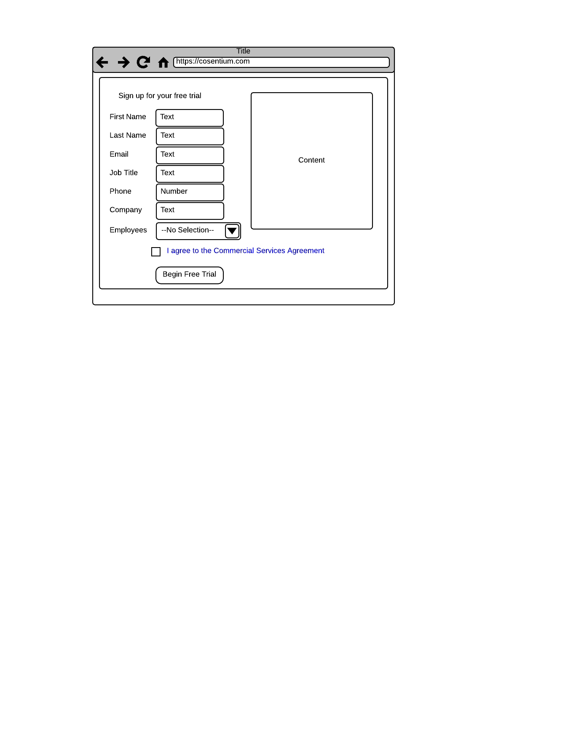

VR1: "Sign up form free trial flow - New Page.png"

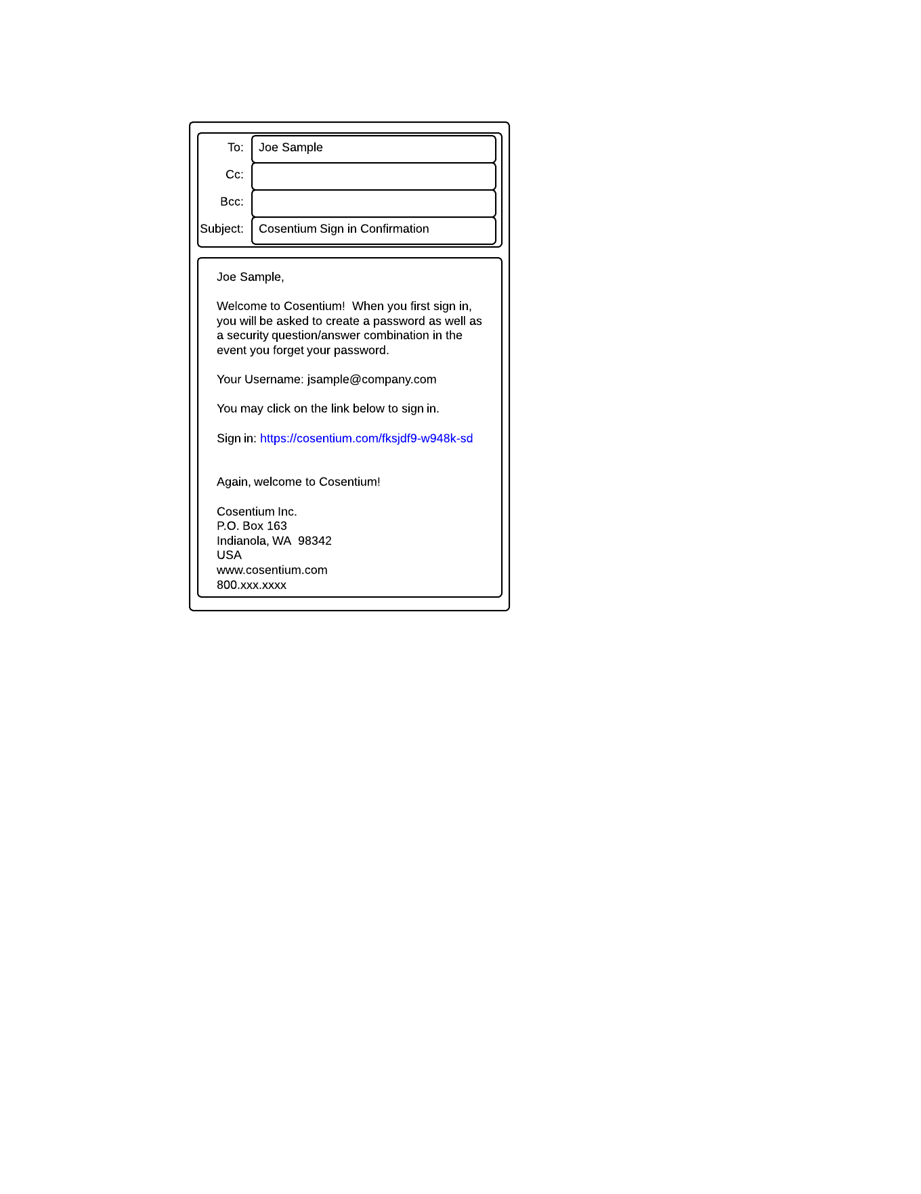

VR2: "Email for free trial signin confirmation - New Page.png"

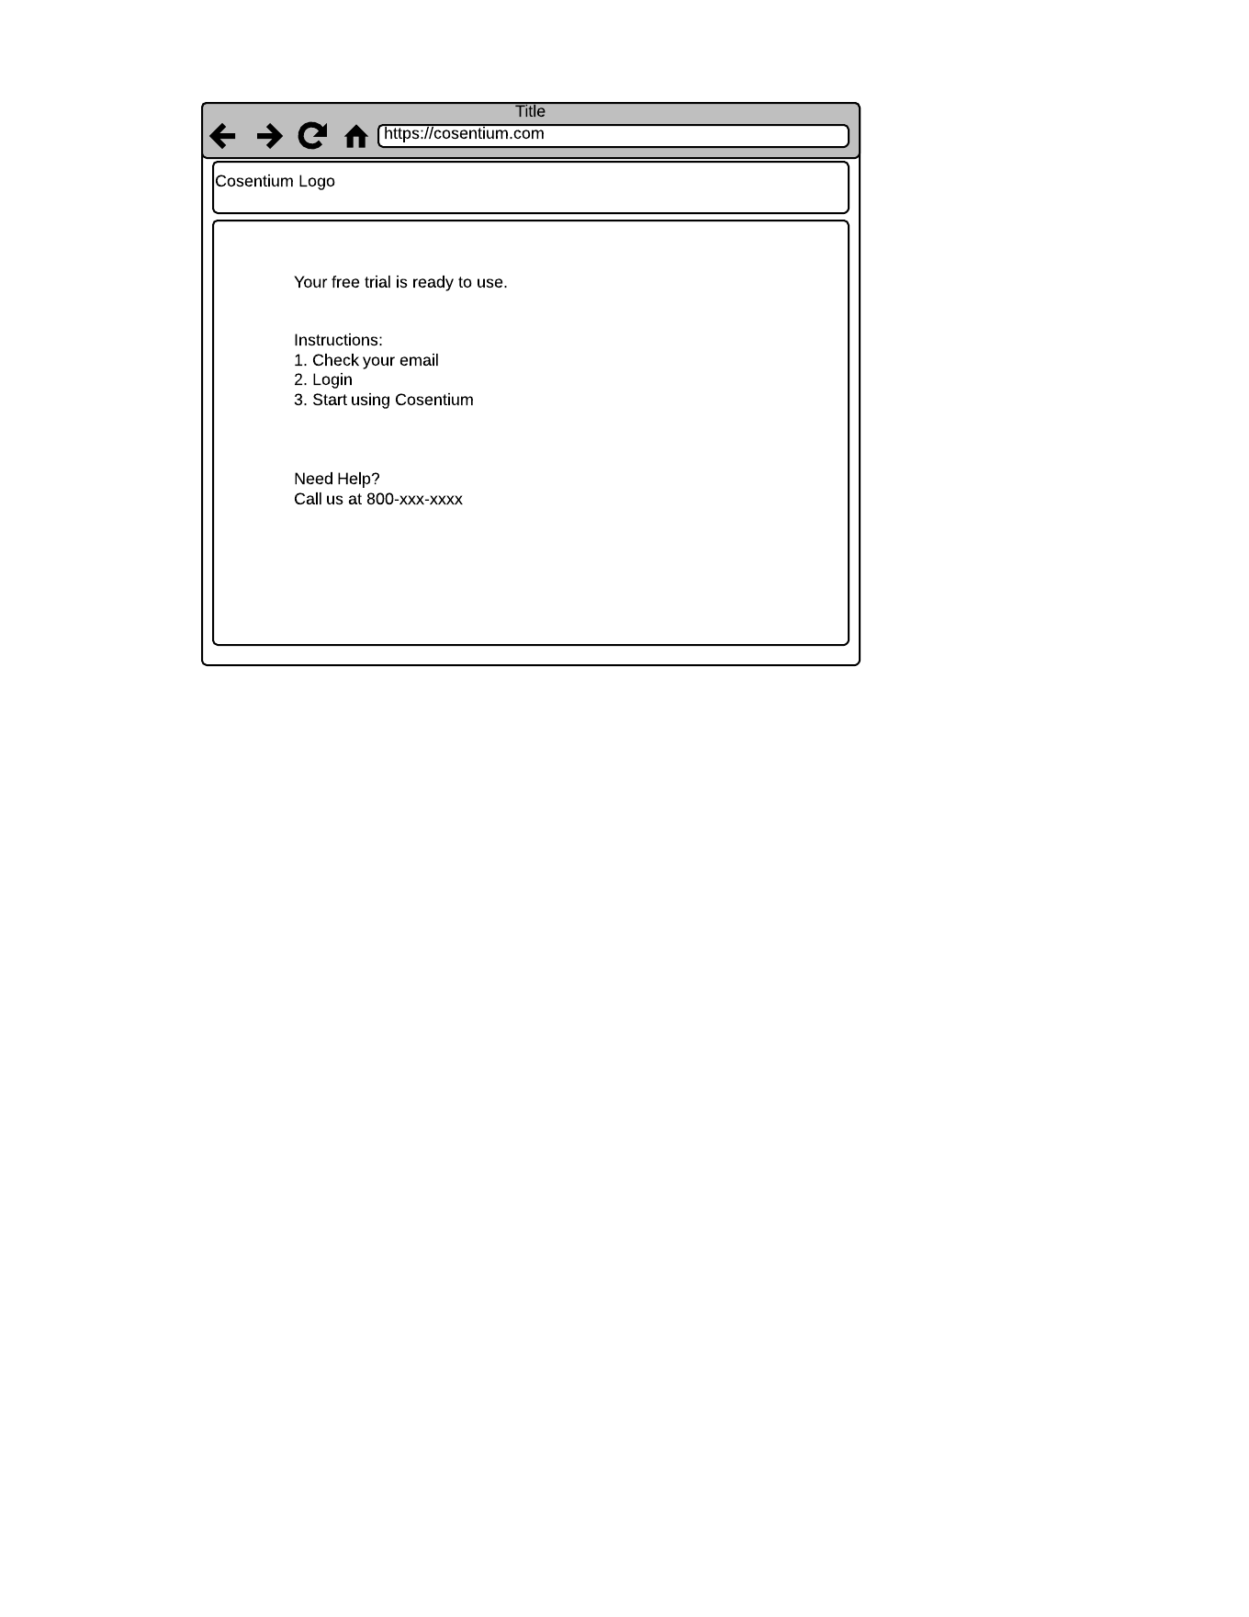

VR3: "splash free trial flow - New Page.png"

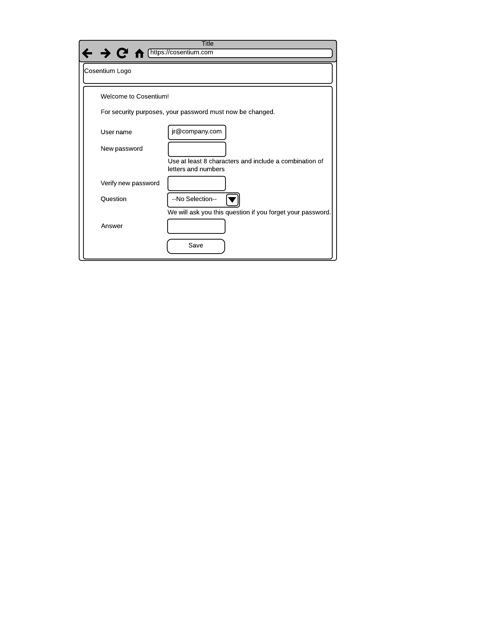

VR4: "change password free trial flow - New Page.png"

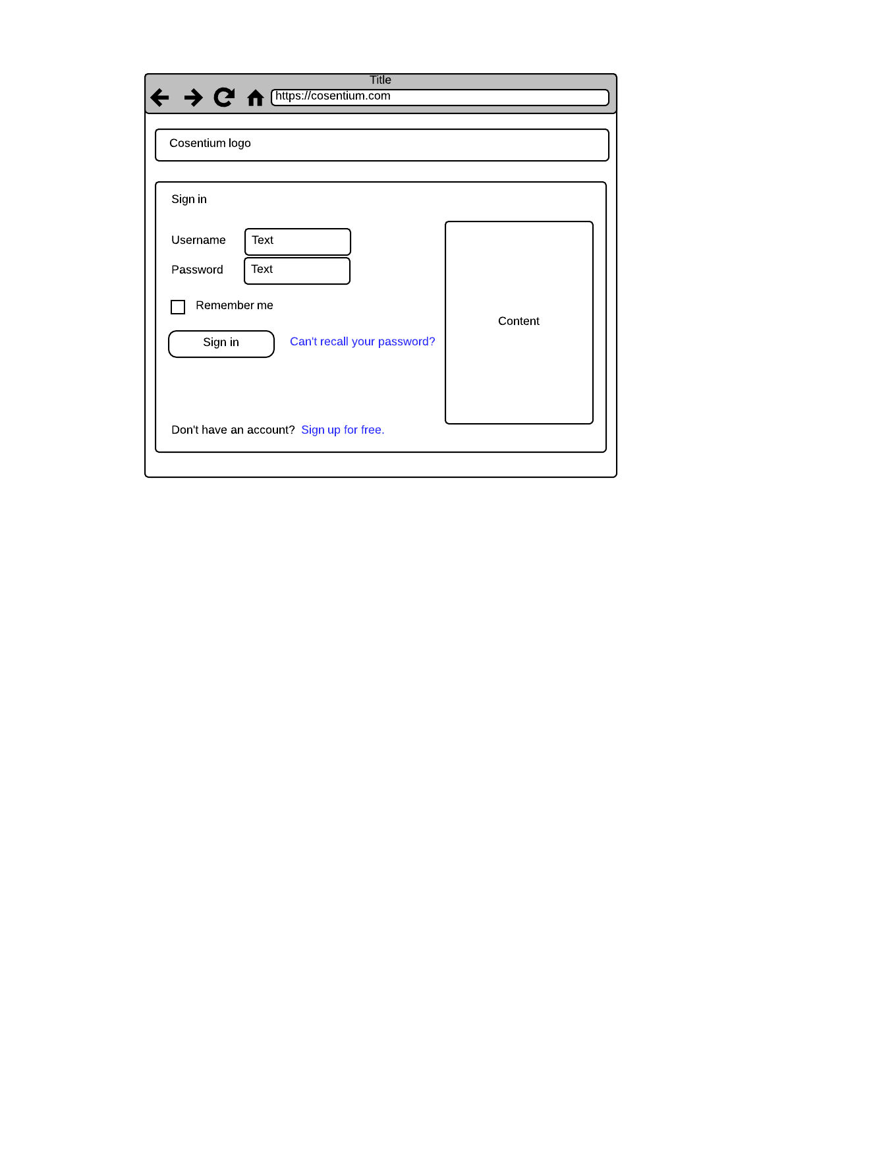

VR5: "login page free trial flow - New Page.png"